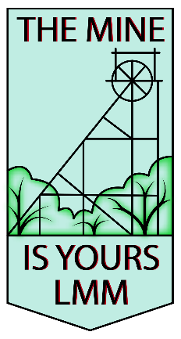 | 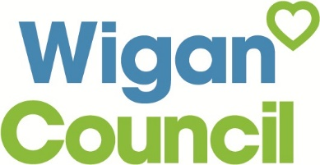 | 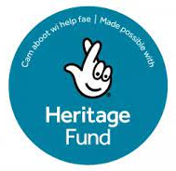 |  | 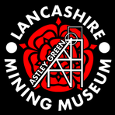

Application to perform at The Mine is Yours Festival

Saturday, 1st October 2022
The Mine Is Yours Festival will be held at the Lancashire Mining Museum, Astley and will involve a range of performances over a number of locations at the festival site. We are looking for a range of artists, preferably with local connections, to perform throughout the day, from 11.00am through to 6.30pm. We will also require a few artists from 7pm – 9.30pm. The acts that we are looking for will cover the range from traditional performances to contemporary arts. Music, poetry, dance and drama are all forms of performance that we would be interested in, as well as demonstrations of traditional crafts and pastimes.
We would love to have you join us

PLEASE ANSWER ALL QUESTIONS.
Once completed please send to themineisyoursfestival@gmail.com with all required information.

No other forms of entry can be accepted.

Artist Name:

Contact Person:

Contact Email:

Contact Telephone:

Website if available:

Preferred Social Media Links:
Music/Video Link if available:
Please give a brief description of what your performance involves, music, drama, dance, poetry etc?
Where are you based?

Where were your most recent performances – if applicable
Brief Description any technical requirements – PA, microphones, equipment etc required for your performance.
Total number of people in act:
We have a number of performance areas, so if you have any special requirements for your performance then please let us know what they are.

What are you prepared and able to do to help publicise the Festival?: This is important, the festival is a collaborative effort and the more people hear about it, the more successful it will be:

Although we are a free festival, funded by donations and fundraising, we are able to pay for reasonable basic expenses for artists travelling to the festival.
Could you please give us an indication of how much you would require in expenses in order to perform at the festival?

Expense request - £

Please attach any of the following information if you have it:
- BIOGRAPHY
- STAGE PLAN & CHANNEL LIST
- PHOTOGRAPH

PLEASE NOTE: The festival is a free entry, family-friendly event – funded by the National Lottery Heritage Fund. Artists are expected to respect this when choosing their material for performance.

Deadline for applications is Monday June 6th. Please send applications to themineisyoursfestival@gmail.com

We aim to inform successful applicants by Friday 30th June!

Thank you.

PLEASE NOTE: the line up of acts appearing at the Festival is decided by a committee of people, all with an individual vote and with individual tastes. No one person on the committee has more influence than any other and therefore approaches to individuals will have no value and may be counterproductive.

